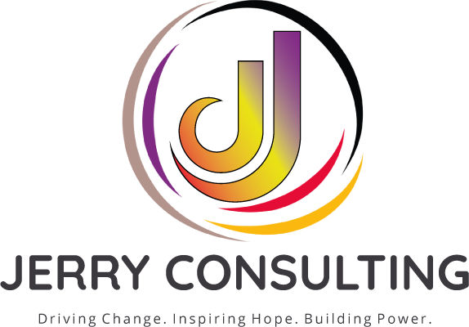
PRIVATE COACHING • TEAM LEARNING • FUNDRAISING STRATEGY
Build the Strategy. Strengthen the Team.
Driving Change. Inspiring Hope. Building Power.
Build the clarity, confidence, strategy, and systems needed to strengthen fundraising and lead sustainable growth. Choose the level of support that matches your goals from one focused conversation to a fully customized organizational engagement.
FOCUSED SUPPORT
STRATEGY POWER HOUR  $300  One 60-minute private session | Includes  - Focused coaching on one fundraising, leadership, board, or communications challenge  - Real-time strategic guidance and recommended next steps  - Concise follow-up summary with priorities and resources  Best for: Nonprofit leaders or fundraisers who need clarity on an immediate decision.

DEEP-DIVE STRATEGY SESSION  $500  One 2-hour private intensive | Includes  - Deeper review of a fundraising goal, campaign, proposal, case, or organizational challenge  - Collaborative problem-solving and strategy development  - Written action priorities to guide implementation  Best for: Leaders who need dedicated space to move from ideas to an actionable direction.

MOMENTUM COACHING  $1,000  One session per week for one month | Includes  - Four private coaching sessions focused on accountability and progress  - Guidance on fundraising strategy, leadership, donor engagement, or professional growth  - Between-session priorities that keep the work moving  Best for: Executives, fundraisers, and emerging leaders building skill, confidence, and momentum.

Instagram • Facebook • LinkedIn • YouTube @consultwithjerry

BUILD THE STRATEGY. STRENGTHEN THE TEAM. EXECUTE THE VISION.
Organizational Coaching & Capacity-Building
FUNDRAISING BLUEPRINT INTENSIVE  $5,000  Meet • Review • Design | Includes  - Leadership discovery meeting and review of current fundraising elements  - Assessment of goals, audiences, revenue opportunities, and organizational readiness  - Customized fundraising plan with priorities, strategies, and recommended next steps  Best for: Organizations that need a clear fundraising direction before launching or expanding their work.

DEVELOPMENT CAPACITY PARTNERSHIP  $10,000  Coaching • Plan • Team Training | Includes  - Executive and development coaching aligned with organizational goals  - Customized development plan and practical implementation priorities  - Interactive team training to strengthen shared fundraising knowledge and accountability  Best for: Organizations ready to align leadership, staff, and fundraising strategy around one plan.

MISSION AMPLIFICATION PARTNERSHIP  $15,000–$20,000  Customized organizational engagement | Includes  - Custom coaching and team development based on organizational needs  - Fundraising strategy, development planning, and implementation support  - Marketing and communications execution aligned with donor engagement and revenue goals  Best for: Organizations seeking integrated support across leadership, fundraising, and communications.

WHY JERRY CONSULTING GROUP  - 29 years of nonprofit, association, and grassroots experience  - $18.5M+ raised in support of mission-driven organizations  - National expertise in fundraising, governance, coaching, and communications  - Relationship-centered guidance grounded in ethical fundraising practice | READY TO BUILD WHAT'S NEXT?  Schedule a conversation to select or customize the right opportunity for you or your team.  consultjerry.com  rochelle@consultjerry.com  Instagram • Facebook • LinkedIn • YouTube  @consultwithjerry
Final scope, schedule, and deliverables are confirmed through a written agreement. Custom engagements are priced according to organizational goals and execution needs.

